**Learning Objectives**

* Be able to calculate standard errors for means and proportions
* Be able to form appropriate conclusions based on sampling distribution information

# Sampling Distribution for MEANS

The **average** annual salary in the automotive industry is **$71,000**, with a **standard deviation of**

**$14,000**. A union official wants to encourage workers in the industry to join the union. She claims that union members in the automotive industry, on average, earn more than $71,000. In order to support her claim, she takes a random sample of 50 union members and records their annual salary. The average salary in her sample is $74,000.

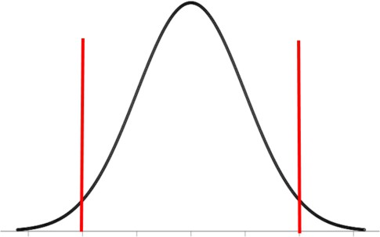

Should we expect to see a normal distribution? Why / Why not?

* Answer:

Calculate the standard error for sample means using the equation: 𝝈𝑴 = √𝒏

You may wish to use the sampling distribution above to answer the following questions.

𝝈

1. If the mean salary of union members is $71,000, is it likely that in a random sample of 50 union members the average salary would be as high as $74,000? Justify your answer.
2. Assuming that the sample was randomly selected from union workers in the automotive industry, and that the annual salaries were correctly recorded, what can we conclude from this? Be as specific as possible and justify your answer.

# Sampling Distribution for PROPORTIONS

In mainland Australia in general, 75% of households have an air-conditioner. It is thought that households in Tasmania are less likely than mainland Australian households to have an air-conditioner. An environmental consultant selected a random sample of 50 Tasmanian households and recorded whether or not they had an air-conditioner. Thirty-one of the 50 households selected have an air-conditioner.



Check for normality using: ***np* ≥ 10, and *n*(1 – *p*) ≥ 10**

𝒏

Calculate the standard error for the sample proportion using the equation: 𝝈𝒑^ = #𝒑 𝙭 (𝟏–𝒑)

You may wish to use the sampling distribution above to answer the following questions.

1. If 75% of households have an air-conditioner, is it likely that in a random sample of 50 Tasmanian households the percentage of households with an air-conditioner would be as low as in the sample obtained by the environmental consultant? Justify your answer.
2. Assuming that the sample was randomly selected from Tasmanian households, and that the information was recorded correctly, what can we conclude from this? Be as specific as possible and justify your answer.